Vak: Databases and Reporting

Docent: Sjors Goossens

Gemaakt door:

Daan Bijl SN 640676,

Lauren Meenhorst SN 632206

ICA Nijmegen - Klas 1E

December 2019

*Power BI Screenshots*

Table of Contents

5A) 2

5A 3

5B 3

5C 4

5D 4

# 5A)

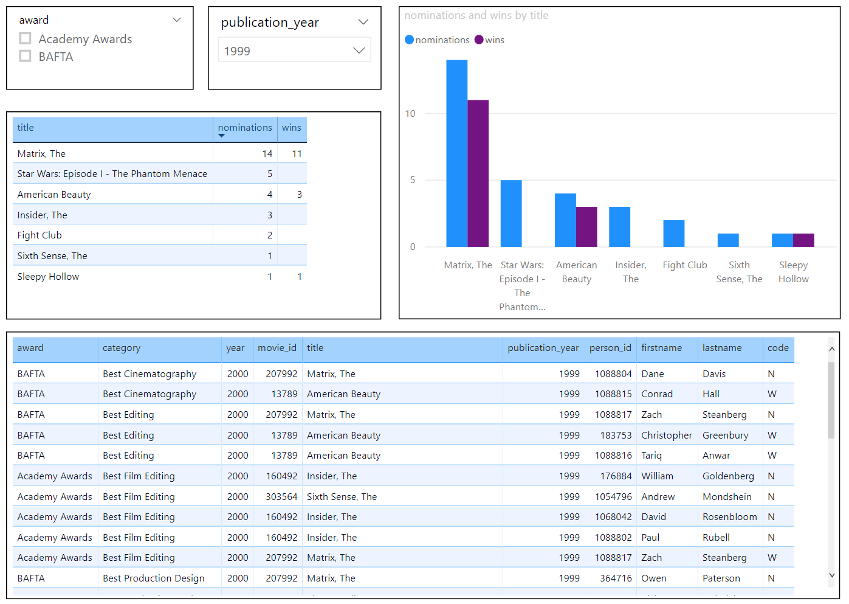

# 5A

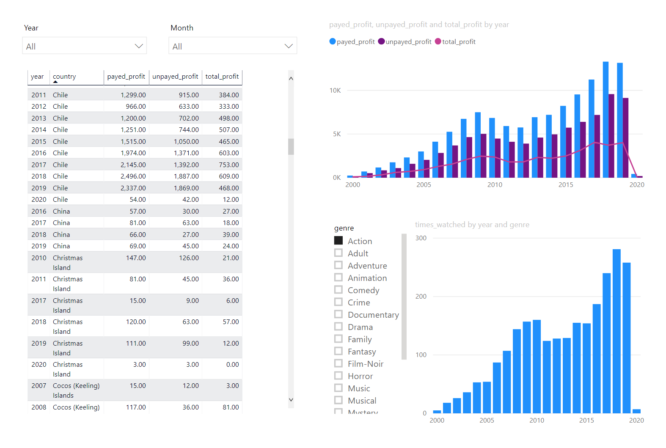

# 5B

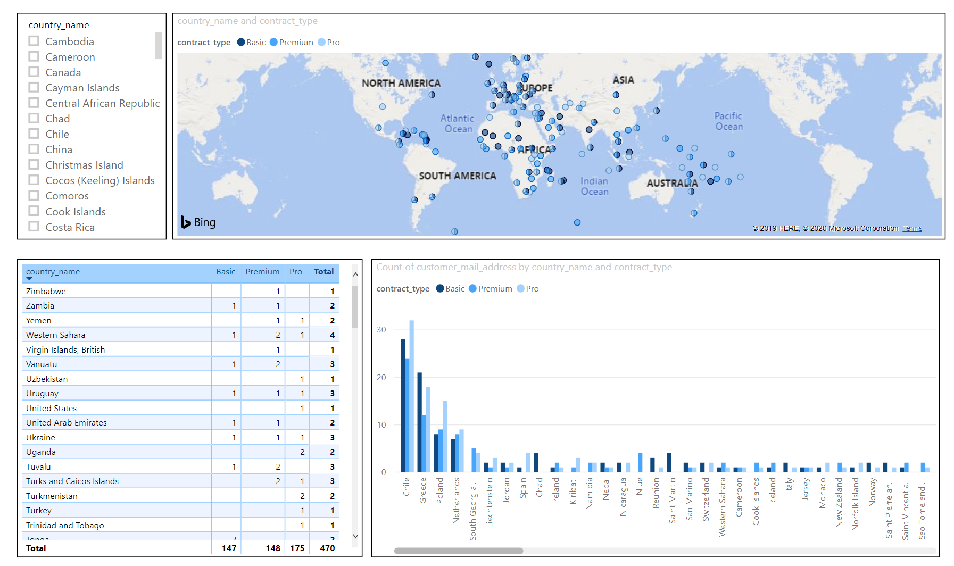

# 5C

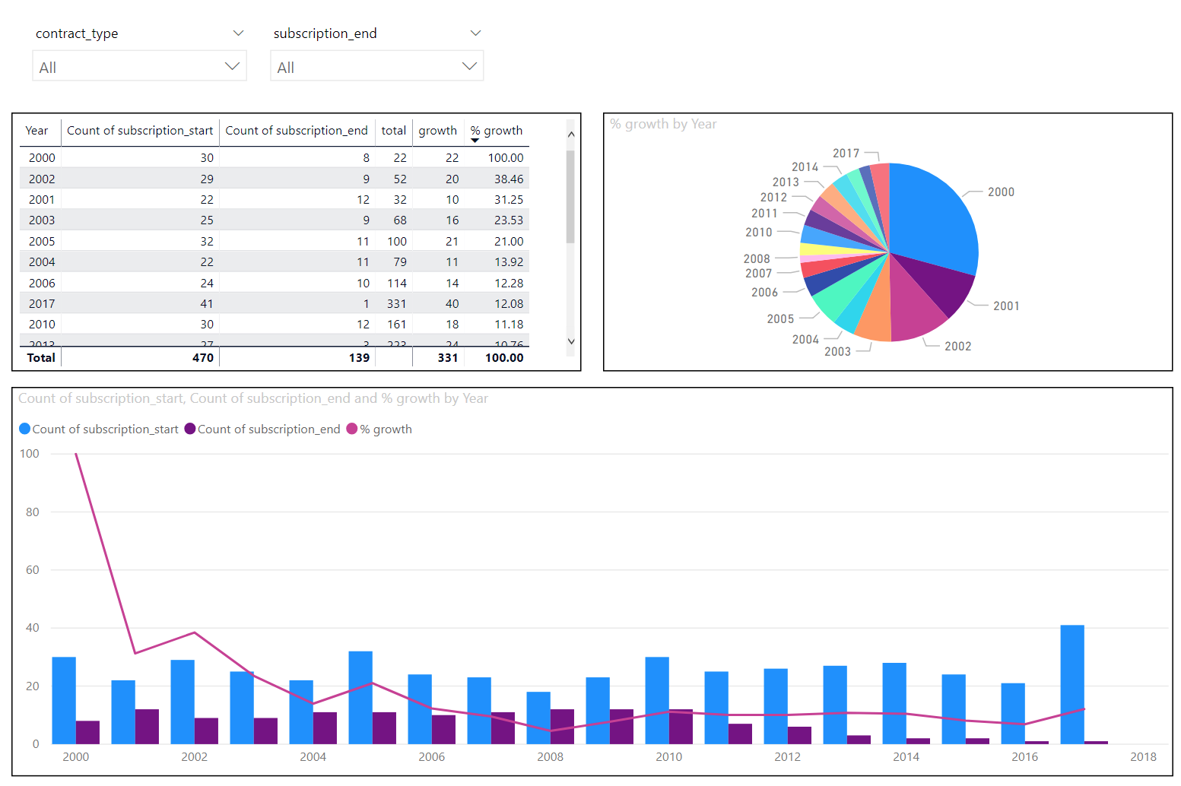

# 5D

